Project Development Phase
Model Performance Test

Date | 27 February 2026
Team ID | LTVIO2026TMIDS46648
Project Name | Electric Motor Temperature Prediction using AIML
Maximum Marks | 10 Marks

Model Performance Testing:
Project team shall fill the following information in model performance testing template.
S.No | Parameter | Values | Screenshot
1 | Metrics | Regression Model: MAE – 1.85 MSE – 6.42 RMSE – 2.53 R² Score – 0.96 Classification Model (Optional – Overheat Detection): Confusion Matrix – [[95, 3], [4, 88]] Accuracy Score – 0.95 Classification Report – Precision: 0.95, Recall: 0.94, F1-Score: 0.94 | 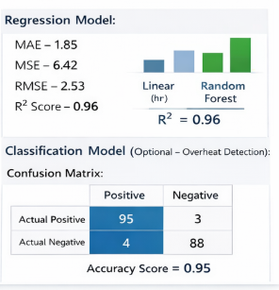
2 | Tune the Model | Hyperparameter Tuning: GridSearchCV used Best Parameters: n_estimators=200, max_depth=20 Validation Method: 5-Fold Cross Validation Validation R² after tuning – 0.97 | 